Angle Between a Line and a Plane
# Source: AI Source: Provided by: [Data Path: Persons Table -> ID Column: 1, Name_En Column: Motasem Essam] -> From: [ChatGPT] on [7/25/2026]
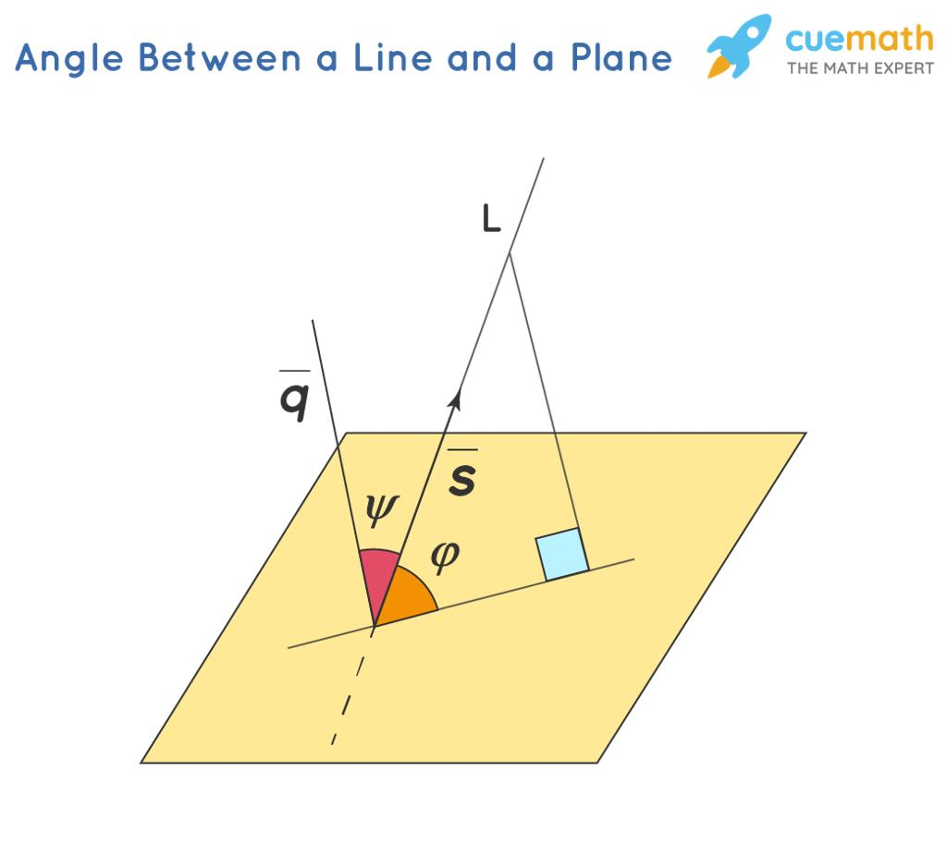
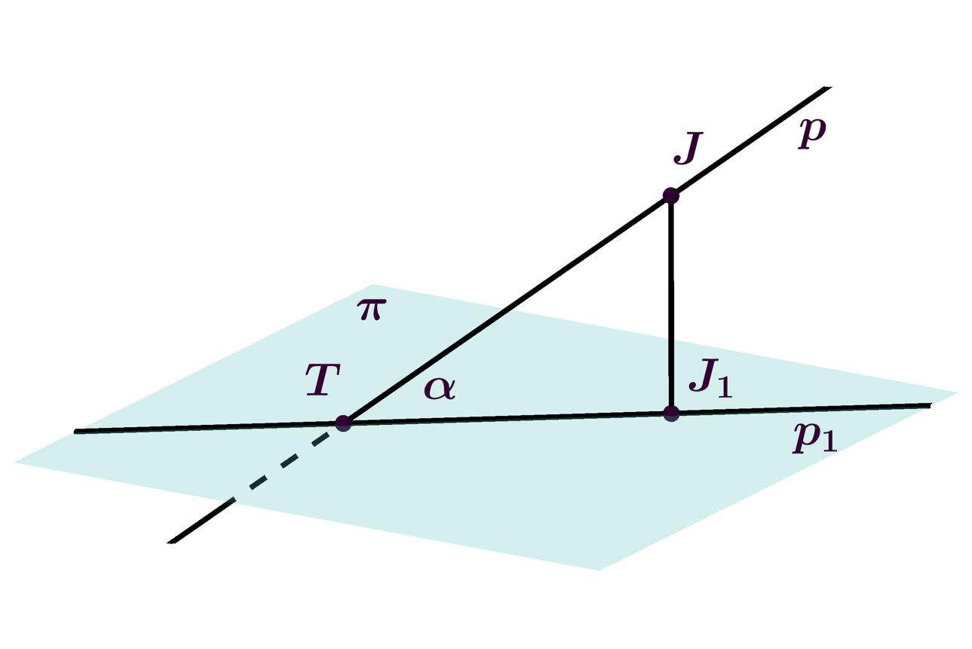
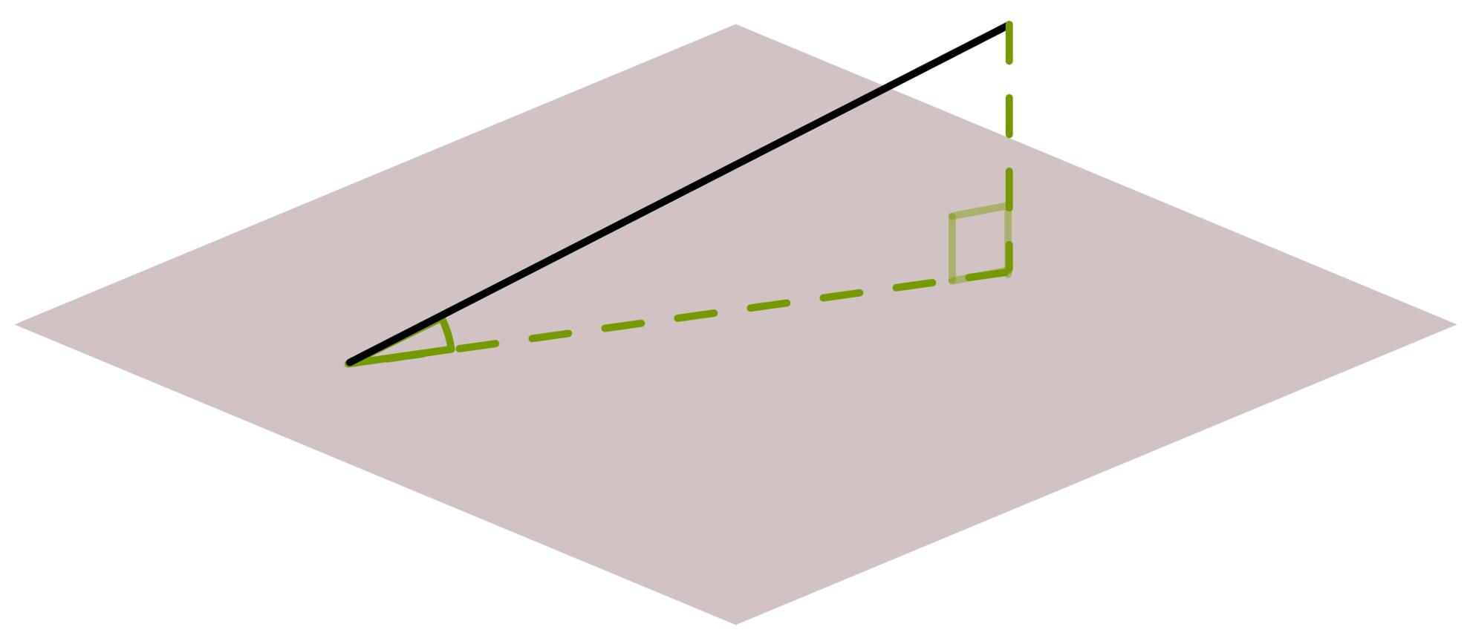

Definition
# Source: AI Source: Provided by: [Data Path: Persons Table -> ID Column: 1, Name_En Column: Motasem Essam] -> From: [ChatGPT] on [7/25/2026]
The angle between a line and a plane is the acute angle formed between the line and its orthogonal projection onto the plane.
The angle is measured between the line and the line segment or line direction obtained by projecting it perpendicularly onto the plane. It describes how steeply the line is inclined relative to the plane.
If a line is perpendicular to the plane, the angle is ${90}^{∘}$. If a line is parallel to or contained in the plane, the angle is $0^{∘}$.

Simple Definition
# Source: AI Source: Provided by: [Data Path: Persons Table -> ID Column: 1, Name_En Column: Motasem Essam] -> From: [ChatGPT] on [7/25/2026]
Imagine a straight stick leaning against a flat floor.
- If the stick lies flat along the floor, the angle is $0^{∘}$.
- If the stick rises diagonally from the floor, the angle is between $0^{∘}$ and ${90}^{∘}$.
- If the stick stands straight up, perpendicular to the floor, the angle is ${90}^{∘}$.
The angle between the stick and the floor represents the angle between a line and a plane.

Key Characteristics
# Source: AI Source: Provided by: [Data Path: Persons Table -> ID Column: 1, Name_En Column: Motasem Essam] -> From: [ChatGPT] on [7/25/2026]
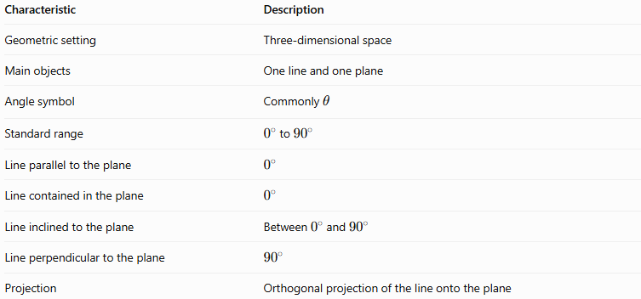
Characteristic | Description
Geometric setting | Three-dimensional space
Main objects | One line and one plane
Angle symbol | Commonly $θ$
Standard range | $0^{∘}$ to ${90}^{∘}$
Line parallel to the plane | $$0^{∘}$$
Line contained in the plane | $$0^{∘}$$
Line inclined to the plane | Between $0^{∘}$ and ${90}^{∘}$
Line perpendicular to the plane | $${90}^{∘}$$
Projection | Orthogonal projection of the line onto the plane

Geometric Representation
# Source: AI Source: Provided by: [Data Path: Persons Table -> ID Column: 1, Name_En Column: Motasem Essam] -> From: [ChatGPT] on [7/25/2026]
Consider a plane $α$ and a line $AB$ that intersects the plane at point $B$. Suppose point $A$ lies outside the plane.
Let $A'$ be the perpendicular projection of $A$ onto the plane.
The projection of line $AB$ onto the plane is line $A'B$, assuming $B$ already lies on the plane. The angle between $AB$ and $A'B$ is the angle between the line and the plane.
Schematic illustration: the angle $θ$ is measured between the line $AB$ and its projection $A'B$ on the plane.
The key idea is that the angle is measured against the projection of the line on the plane, not against the perpendicular from the line to the plane.

Mathematical Representation and Formulas

A. Using the line's direction vector and the plane's normal vector
# Source: AI Source: Provided by: [Data Path: Persons Table -> ID Column: 1, Name_En Column: Motasem Essam] -> From: [ChatGPT] on [7/25/2026]
Let the direction vector of the line be
$$d=\left(a,b,c\right)$$
and let the normal vector of the plane be
$$n=\left(A,B,C\right).$$
A normal vector is perpendicular to every direction lying in the plane.
If $θ$ is the angle between the line and the plane, then
$$\boxed{\sin{θ}=\frac{\left|d⋅n\right|}{\left\|d\right\|\left\|n\right\|}}$$
Therefore,
$$\boxed{θ=\sin^{-1}\left(\frac{\left|d⋅n\right|}{\left\|d\right\|\left\|n\right\|}\right)}$$
The sine is used because the angle between the line and the plane is complementary to the angle between the line and the plane's normal direction.

B. Using a plane equation
# Source: AI Source: Provided by: [Data Path: Persons Table -> ID Column: 1, Name_En Column: Motasem Essam] -> From: [ChatGPT] on [7/25/2026]
For a plane
$$Ax+By+Cz+D=0,$$
the normal vector is
$$n=\left(A,B,C\right).$$
If the line has direction vector $d=\left(a,b,c\right)$, then
$$\boxed{θ=\sin^{-1}\left(\frac{\left|Aa+Bb+Cc\right|}{\sqrt{A^{2}+B^{2}+C^{2}}\sqrt{a^{2}+b^{2}+c^{2}}}\right)}$$
This formula assumes both vectors are nonzero.

C. Special cases
# Source: AI Source: Provided by: [Data Path: Persons Table -> ID Column: 1, Name_En Column: Motasem Essam] -> From: [ChatGPT] on [7/25/2026]
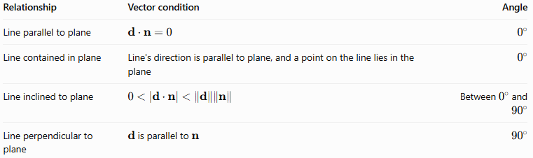
Relationship | Vector condition | Angle
Line parallel to plane | $$d⋅n=0$$ | $$0^{∘}$$
Line contained in plane | Line's direction is parallel to plane, and a point on the line lies in the plane | $$0^{∘}$$
Line inclined to plane | $$0<\left|d⋅n\right|<\left\|d\right\|\left\|n\right\|$$ | Between $0^{∘}$ and ${90}^{∘}$
Line perpendicular to plane | $d$ is parallel to $n$ | $${90}^{∘}$$
Note that a line parallel to a plane does not have to lie in the plane; it may be separated from it.

Worked Examples
# Source: AI Source: Provided by: [Data Path: Persons Table -> ID Column: 1, Name_En Column: Motasem Essam] -> From: [ChatGPT] on [7/25/2026]
Example 1: A line perpendicular to a plane
Suppose a line has direction vector
$$d=\left(0,0,1\right)$$
and the plane is
$$z=0.$$
The plane's normal vector is
$$n=\left(0,0,1\right).$$
The two vectors are parallel, so the line is perpendicular to the plane.
Answer:
$$\boxed{θ={90}^{∘}}$$
Example 2: A line parallel to a plane
Suppose the line has direction vector
$$d=\left(1,2,0\right)$$
and the plane is
$$z=3.$$
The plane's normal vector is
$$n=\left(0,0,1\right).$$
Their dot product is
$$d⋅n=\left(1\right)\left(0\right)+\left(2\right)\left(0\right)+\left(0\right)\left(1\right)=0.$$
Therefore, the line's direction is parallel to the plane. If the line lies outside the plane, it does not intersect it.
Answer:
$$\boxed{θ=0^{∘}}$$
Example 3: Finding an inclined angle
Consider a line with direction vector
$$d=\left(1,0,1\right)$$
and the plane
$$z=0.$$
The plane's normal vector is
$$n=\left(0,0,1\right).$$
Calculate the dot product:
$$d⋅n=1.$$
Calculate the magnitudes:
$$\left\|d\right\|=\sqrt{2}, \left\|n\right\|=1.$$
Apply the formula:
$$\sin{θ}=\frac{1}{\sqrt{2}}.$$
Thus,
$$θ=\sin^{-1}\left(\frac{1}{\sqrt{2}}\right).$$
Answer:
$$\boxed{θ={45}^{∘}}$$
Example 4: Using a plane equation
Find the angle between the line with direction vector
$$d=\left(1,1,0\right)$$
and the plane
$$x+y+z=0.$$
The normal vector is
$$n=\left(1,1,1\right).$$
Calculate the dot product:
$$d⋅n=1+1+0=2.$$
Calculate the magnitudes:
$$\left\|d\right\|=\sqrt{2}, \left\|n\right\|=\sqrt{3}.$$
Therefore,
$$\sin{θ}=\frac{2}{\sqrt{6}}.$$
So,
$$θ=\sin^{-1}\left(\frac{2}{\sqrt{6}}\right).$$
Answer:
$$\boxed{θ≈{54.74}^{∘}}$$

Comparison With Related Concepts
# Source: AI Source: Provided by: [Data Path: Persons Table -> ID Column: 1, Name_En Column: Motasem Essam] -> From: [ChatGPT] on [7/25/2026]
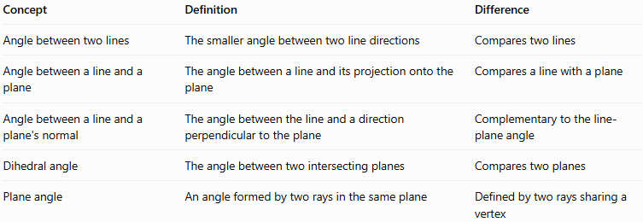
Concept | Definition | Difference
Angle between two lines | The smaller angle between two line directions | Compares two lines
Angle between a line and a plane | The angle between a line and its projection onto the plane | Compares a line with a plane
Angle between a line and a plane's normal | The angle between the line and a direction perpendicular to the plane | Complementary to the line-plane angle
Dihedral angle | The angle between two intersecting planes | Compares two planes
Plane angle | An angle formed by two rays in the same plane | Defined by two rays sharing a vertex
For a line that is neither parallel nor perpendicular to a plane, the angle between the line and the plane's normal is complementary to the line-plane angle:
$$θ+ϕ={90}^{∘}.$$
Here, $θ$ is the line-plane angle and $ϕ$ is the angle between the line and the normal.

Applications
# Source: AI Source: Provided by: [Data Path: Persons Table -> ID Column: 1, Name_En Column: Motasem Essam] -> From: [ChatGPT] on [7/25/2026]
The angle between a line and a plane is useful in many fields:
- Architecture: measuring the inclination of roof beams relative to floors.
- Civil engineering: determining the slope of ramps, roads, and structural supports.
- Mechanical engineering: positioning rods, shafts, and machine components.
- Computer graphics: calculating the orientation of three-dimensional objects.
- Surveying: analyzing the inclination of sight lines relative to horizontal ground.
- Solid geometry: studying diagonals, edges, and axes of three-dimensional solids.

Key Points
# Source: AI Source: Provided by: [Data Path: Persons Table -> ID Column: 1, Name_En Column: Motasem Essam] -> From: [ChatGPT] on [7/25/2026]
- The angle between a line and a plane is measured using the line's projection onto the plane.
- The standard angle lies between $0^{∘}$ and ${90}^{∘}$, inclusive.
- A line parallel to or contained in the plane has angle $0^{∘}$.
- A line perpendicular to the plane has angle ${90}^{∘}$.
- The plane's normal vector is perpendicular to the plane.
- The line-plane angle is complementary to the angle between the line and the normal.
- The sine formula uses the dot product of the line's direction vector and the plane's normal vector.

Conclusion
# Source: AI Source: Provided by: [Data Path: Persons Table -> ID Column: 1, Name_En Column: Motasem Essam] -> From: [ChatGPT] on [7/25/2026]
The angle between a line and a plane describes the inclination of a line relative to a flat surface in three-dimensional space. It is defined using the line's orthogonal projection onto the plane and can be calculated using the direction vector of the line and the normal vector of the plane.
Understanding this angle is essential for analyzing slopes, perpendicularity, and spatial relationships in solid geometry.

